Syed Muhammad Akbar (237544)

msyed.bscs17seecs

Abstract

We used the module file system to manipulate the files on the system

Advance programming LAB 04

FILE SYSTEM

BSCS 7B

My Progress & Code:

TASK 01-02

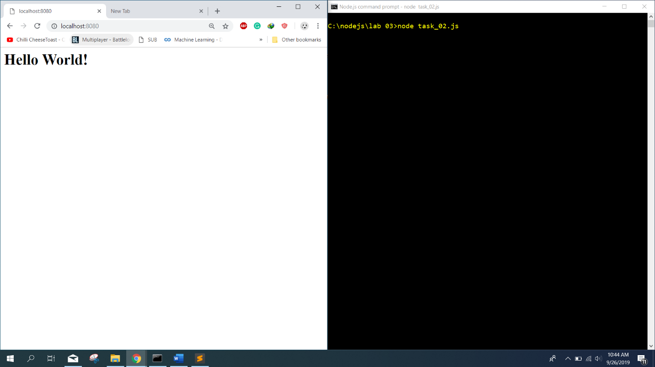

var http = require('http');

http.createServer(function(req, res){

res.writeHead(200, {'content-type':'text/html'});

res.end('<h1>Hello World!</h1>');

}).listen(8080);

TASK 02-03

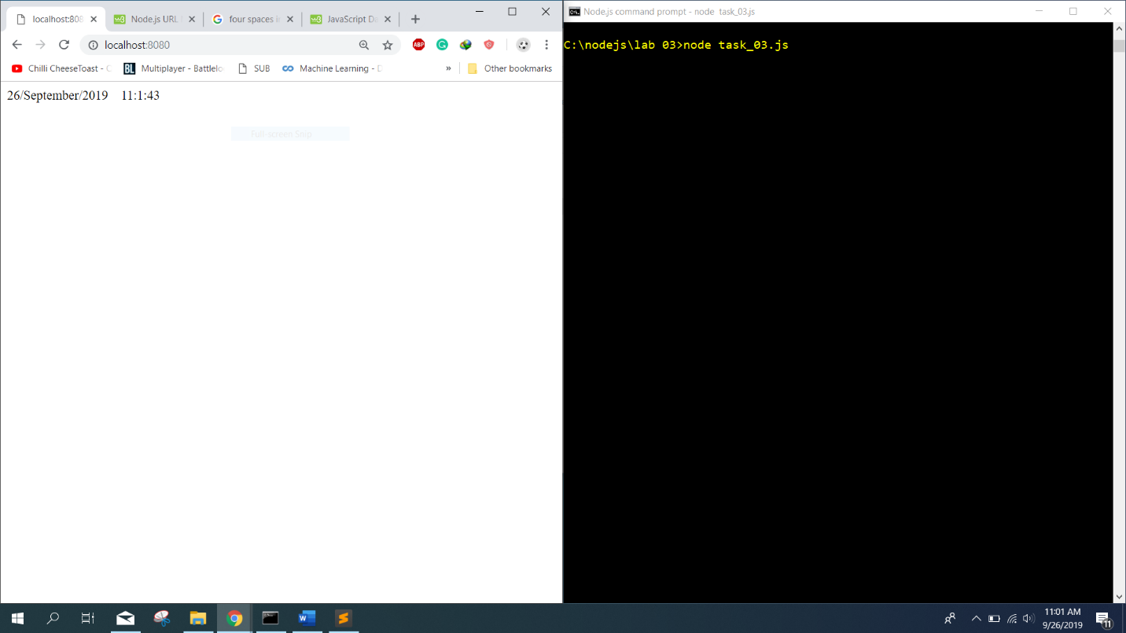

var http = require('http')

var dt = require('./myfirstmodule')

http.createServer(function(req, res){

res.writeHead(200, {'content-type':'text/html'});

res.end('<p>'+dt.dateAndTime()+'</p>');

}).listen(8080);

TASK 04-05:

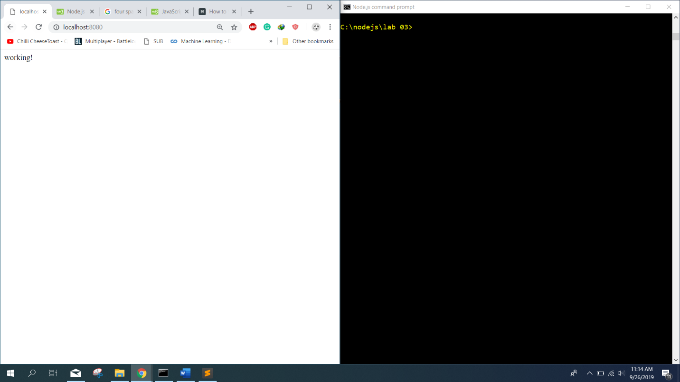

var http = require('http');

http.createServer(function(req, res){

res.writeHead(200, {'content-type':'text/html'});

res.end('working!');

}).listen(8080);

TASK 06-07:

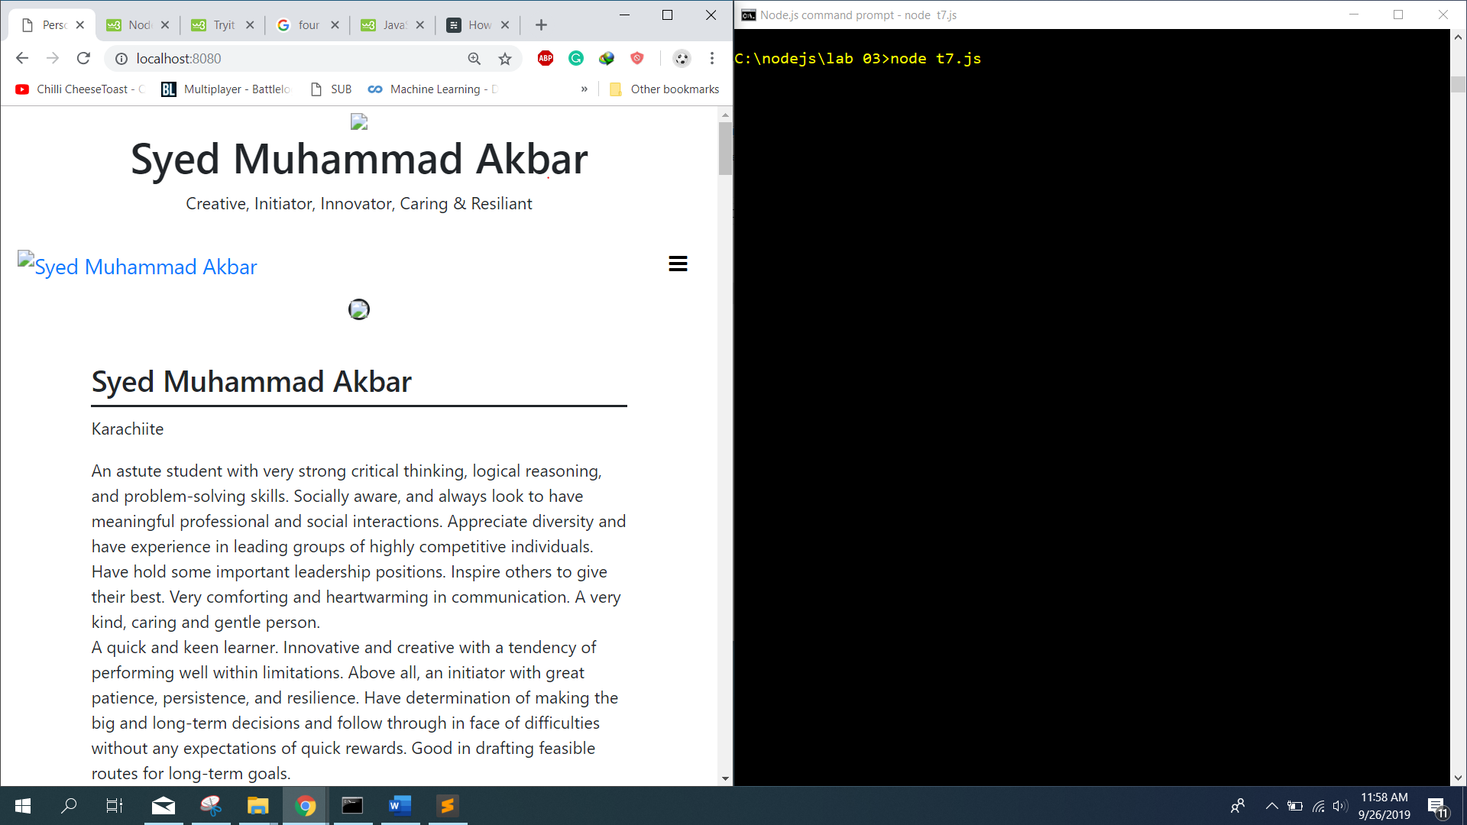

var http = require('http');

var fs = require('fs');

http.createServer(function(req, res){

fs.readFile('personal website/index.html', function(err, data){

if (err) throw err;

res.writeHead(200, {'content-type':'text/html'});

res.write(data);

res.end();

});

}).listen(8080);

TASK 08:

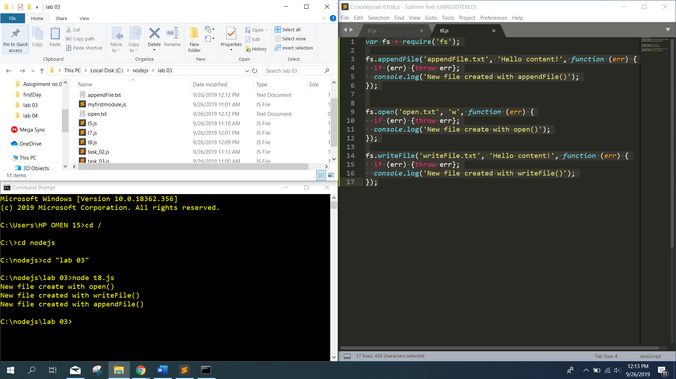

var fs = require('fs');

fs.appendFile('appendFile.txt', 'Hello content!', function (err) {

if (err) {throw err};

console.log('New file created with appendFile()');

});

fs.open('open.txt', 'w', function (err) {

if (err) {throw err};

console.log('New file create with open()');

});

fs.writeFile('writeFile.txt', 'Hello content!', function (err) {

if (err) {throw err};

console.log('New file created with writeFile()');

});

TASK 09:

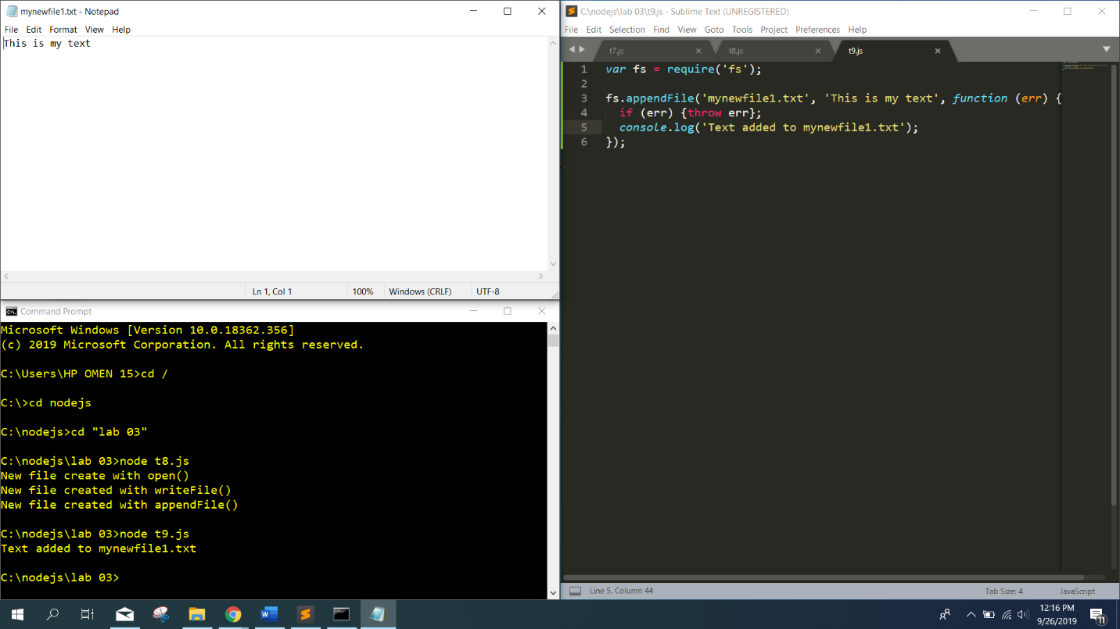

var fs = require('fs');

fs.appendFile('mynewfile1.txt', 'This is my text', function (err) {

if (err) {throw err};

console.log('Text added to mynewfile1.txt');

});

TASK 10:

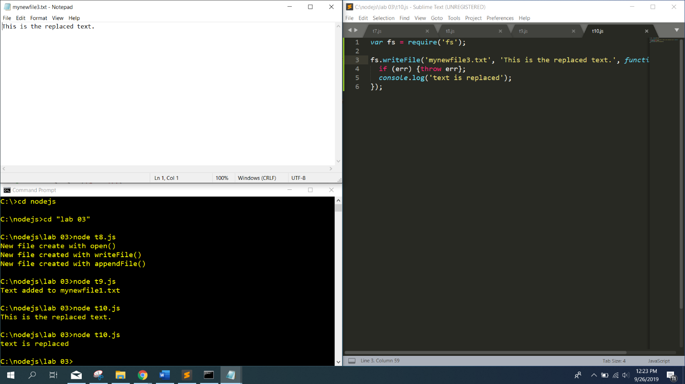

var fs = require('fs');

fs.writeFile('mynewfile3.txt', 'This is the replaced text.', function (err) {

if (err) {throw err};

console.log('text is replaced');

});

TASK 11:

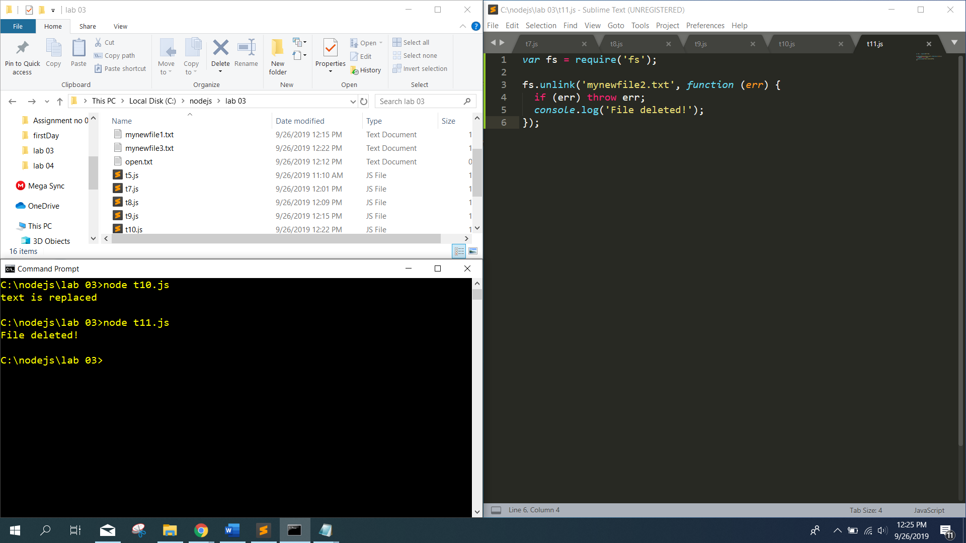

var fs = require('fs');

fs.unlink('mynewfile2.txt', function (err) {

if (err) throw err;

console.log('File deleted!');

});

TASK 12:

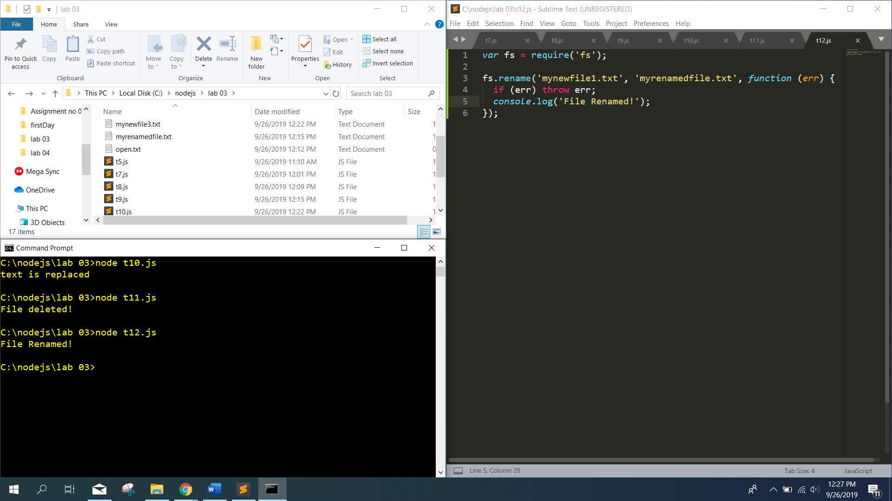

var fs = require('fs');

fs.rename('mynewfile1.txt', 'myrenamedfile.txt', function (err) {

if (err) throw err;

console.log('File Renamed!');

});